# *Happy Hoof Prints* Design Document

# Strategy

## Aim

Promote the Happy Hoof Prints riding school services via the web predominantly advertising their group rides.

## Business Objectives

1. Increase participants on group rides
2. Increase the yards reputation in the equestrian community
3. Increase participant using the yards support services (lessons, competitions)
4. Allow group rides availability to be viewed online and rides booked and paid for
5. Show the yard off to the equestrian community promoting the great location
6. Provide news updates and portray the family values of the yard
7. Show the yard as professional and friendly
8. Build up contact list for updates etc

## Likely features

* Lots of pictures of the yard
* Yard blog/news update easy to update
* Calendar of group rides easy to update
* Calendar of yard activities easy to update
* Information about group rides and ability to book
* Yard contact details
* List of yard services and promotion of livery packages
* Contact form
* Yard web cams
* Check availability and pay online
* Book competition entries online
* Meet the team

## Yard Features to get across

* Yard mission statement/vision
* Happy
* Safe and family run
* Horses large variety for different abilites
* Safe storage of items
* Ample parking
* Insured
* Good quality safety and riding gear
* Very scenic location
* Horse well looked after with good grazing
* Friendly atmosphere
* Regular competitions
* Indoor and outdoor schools
* Hacking from doorstep
* Little road work
* Tea area
* Secure storage of tack
* Qualified staff

## Target Audience

|  |  |  |  |
| --- | --- | --- | --- |
|  | Features | Needs | Tech |
| Tourists | Mix of purchasing types impulse to planned. Likely to be families and older people making buying choices. Some will be planned prior to trip most would be impulse ‘casual riders’ looking for something to do | Clear information to make a choice. Understand what they are getting in terms of quality, a good time, professional organisation. Any risks, how much it will cost, are they getting value. Safety for themselves and welfare of animals | Likely to be mobile device as they would be on holiday. |
| Equestrian Community | Age likely to be mixed, equestrian community 18-50 | Not their needs but the horses needs first then does it provide the services they need which would be mixed depending on the rider. | Range of devices |

|  |  |  |  |
| --- | --- | --- | --- |
| **Feature** | **importance** | **viability** | **Score** |
| Good images that sell services | 5 | 5 | 25 |
| Calendar of yard activities | 3 | 5 | 15 |
| Yard news | 2 | 5 | 10 |
| Group rides info | 5 | 5 | 25 |
| Group rides booking online | 5 | 2 | 10 |
| Contact form | 5 | 5 | 25 |
| Videos of services | 5 | 5 | 25 |
| Yard web cams | 2 | 2 | 4 |
| List of yard services | 4 | 5 | 20 |
| Promotion of livery | 4 | 5 | 20 |
| Book competition entries online | 3 | 1 | 3 |
| E mail signup | 4 | 4 | 16 |
| Staff details |  |  |  |

# Scope

## Difficulty rating

|  |  |  |  |  |
| --- | --- | --- | --- | --- |
| **Feature** | **Score** | **Difficulty** | **In/Out** | **Phase 2** |
| Good images that sell services | 25 | 2 |  |  |
| Group rides info | 25 | 2 |  |  |
| Contact form | 25 | 3 |  |  |
| Videos of services | 25 | 2 |  |  |
| List of yard services | 20 | 2 |  |  |
| Promotion of livery | 20 | 2 |  |  |
| Calendar of yard activities | 15 | 3 |  |  |
| Yard news | 10 | 2 |  |  |
| Group rides booking online | 10 | 4 |  |  |
| Yard web cams | 4 | 5 |  |  |
| Book competition entries online | 3 | 4 |  |  |
| E mail sign up | 16 | 3 |  |  |
| Meet the team | 25 | 2 |  |  |

## Risks

* GDPR compliance for subscription and collection of data. The business currently has no provision for data collection.
* Google rankings will help to establish the business but this may be problematic without a clear strategy from the design phase

# Structure

How to confirm form submission??

Central traditional nav on all pages

The home page should have previews for each section with links. Contact stand out feature on home page for quick booking. Navigation should be bold and simple to show the services on offer. Home page should be mainly visual to grab the user so strong riding image. Navigation and layout should be intuitive and follow established design .

The booking forms will take the form of a modal

**Form Information**

|  |  |  |
| --- | --- | --- |
| **Group Ride** | **Comp** | **General Livery** |
| **Name**  **E mail**  Contact number  Ride type  Ride Date  Number of people  Any other info | **Name**  **E mail**  Contact Number  Comp name  Number of entries  Horse Name (multiples  Any other info | **Name**  **E mail**  Contact number  Enquiry |

Required

## Use-cases

See appendix A

# Layout

## Wireframes

**Home Page**

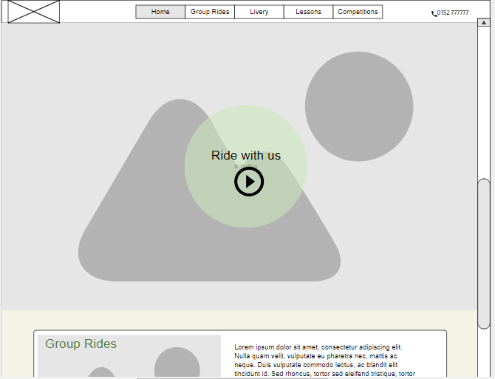

Logo

**Content Page**

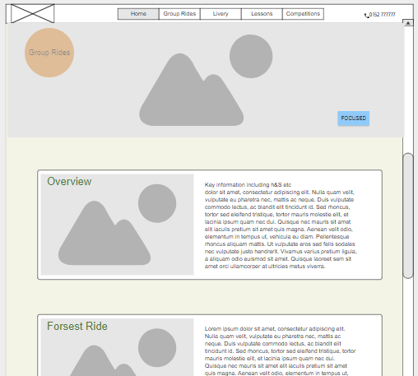

Fixed header

Book Button

# Surface Design

## Wireframes

**Text –** Raleway, lato, indie flower

**Principle colours –** Orange, grey, white, green

All pages will contain a 80% height images to really show off the school and local area.

Graphic images will be used to display key services

Font Awsome icons will be used for social media in the footer

Footer will contain a grass background to add texture to the site

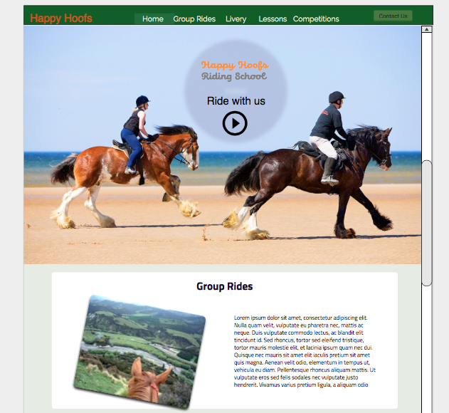

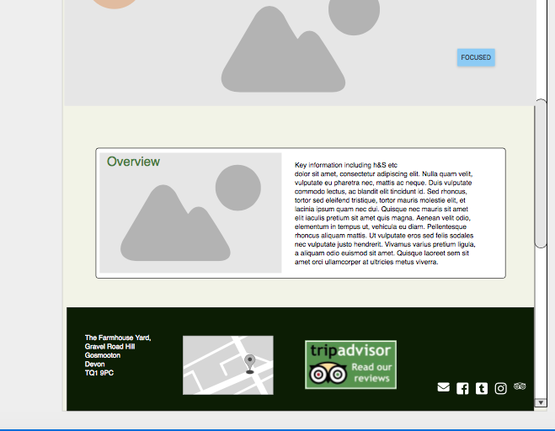

# Appendix A Use Cases

# Use Case 01

|  |
| --- |
| Name |
| Finding services |

|  |
| --- |
| Description |
| User wants to find out about the services |

|  |
| --- |
| Actors |
| User |
|  |

|  |
| --- |
| Priority |
| Important to user they can find their way easily |

|  |
| --- |
| Pre conditions |
| None |

|  |  |  |
| --- | --- | --- |
| Flow of events | | |
|  | | |
| Step | User Action | System response |
| 1. | User arrives on home page |  |
| 2. | Areas clearly signposted in nav user clicks | Taken to page |
|  |  |  |

# Use Case 02

|  |
| --- |
| Name |
| Booking a group ride or competition |

|  |
| --- |
| Description |
| User wants to book |

|  |
| --- |
| Actors |
| User |
| Yard admin |

|  |
| --- |
| Priority |
| Clear booking information and one click |

|  |
| --- |
| Pre conditions |
| User must have selected activity |

|  |  |  |
| --- | --- | --- |
| Flow of events | | |
|  | | |
| Step | User Action | System response |
| 1. | User arrives on home page |  |
| 2. | Clicks to booking for relevant type from feature or | taken to clicked relevant contact form |
| 3 | Clicks to info page for interest |  |
| 4 | Clicks link to booking page | Taken to relevant booking page |
| 5 | Visual confirmation of submission |  |

# Use Case 03

|  |
| --- |
| Name |
| General Enquiry |

|  |
| --- |
| Description |
| User has a question not answered on site |

|  |
| --- |
| Actors |
| User |
| Yard admin |

|  |
| --- |
| Priority |
| Easy to contact in person |

|  |
| --- |
| Pre conditions |
| User should easily be able to call |

|  |  |  |
| --- | --- | --- |
| Flow of events | | |
|  | | |
| Step | User Action | System response |
| 1. | Telephone number and contact should be signposted all pages |  |
| 2. |  |  |
| 3 |  |  |
| 4 |  |  |